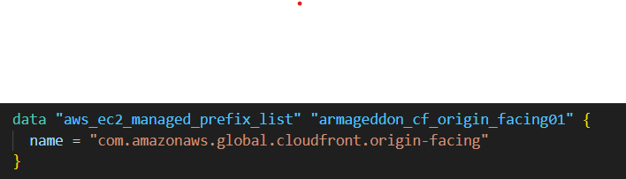
- This does not create anything. It looks up an AWS-managed prefix list.
- com.amazonaws.global.cloudfront.origin-facing is a published set of IP ranges CloudFront uses when it connects to your origin.
- You typically use data.aws_ec2_managed_prefix_list...id in a security group rule like:
  - “Allow inbound 443 to the ALB only from this prefix list”
- In the snippet you pasted, you’re only defining the data source; the actual SG rule that uses it would be elsewhere.
Purpose: lock your ALB down so random internet clients can’t hit it directly—only CloudFront can.
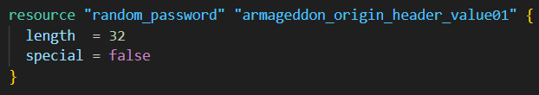
- Creates a random 32-character string (letters/numbers).
- special = false means no symbols like !@#$... (often done to avoid escaping/compat issues).
- Terraform stores the generated value in state and exposes it at:
  - random_password.armageddon_origin_header_value01.result
Purpose: this becomes a secret token you require on requests reaching the ALB.
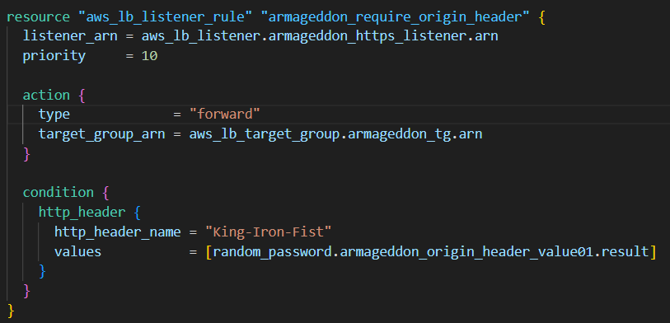
- Adds a rule to your HTTPS listener on the ALB.
- Priority 10 means it’s evaluated before rules with higher numbers (like 99).
- Condition: request must include header:
  - King-Iron-Fist: <the-random-secret>
- If the header matches, the ALB forwards the request to your target group (armageddon_tg).
Purpose: even if someone somehow reaches your ALB, they still can’t get forwarded to your app unless they know the secret header value.
This only works if CloudFront is configured to add that header to origin requests (in your CloudFront origin “custom header” settings).
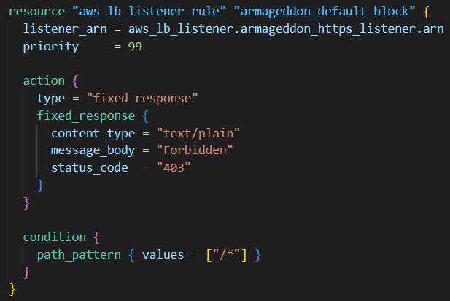
- Another listener rule on the same listener.
- Matches all paths (/*).
- Returns a 403 Forbidden fixed response.
Purpose: anything that doesn’t match the secret-header rule gets blocked.
Why priority matters: ALB evaluates from lowest priority number upward.
- If header matches → priority 10 rule forwards
- Otherwise → it falls through and priority 99 blocks

